12/16/2025 Beyer Music Booster Parent
Meeting Agenda

Attend virtually
Microsoft Teams Need help?
Join the meeting now
Meeting ID: 935 657 925 271 3
Passcode: HG9Qt6
Download Teams | Join on the web
Learn More | Meeting options

Meeting called to order at: 6:32 pm
Location: (If Little Theater is unavailable, we will meet in the piano room at Beyer)

Attendees- Alli Campbell, Kim Ricci, Amanda and Bobby Coons, Mr. Medina, Anthony Zepeda, Cheralynn Morrison, Jeff Tallcott, Tonya Barnard, Lauren Odermatt, Daiza Macias, Ashton Martinez, Rainbow and Christian Valentin, Beth Lyons-McCarthy, Kris (online)

- Approval of previous minutes
  - 11/18/2025 Beyer Booster Parent Meeting
    - 1st Kim
    - 2nd Lauren

- Treasurer Report – Amanda Coons
  - Band Boosters Treasurer Reports 24-25.xlsx
  - Winter Budget
    - Total expenses of $8675/34 students= $255.15
    - Fair Share= $260
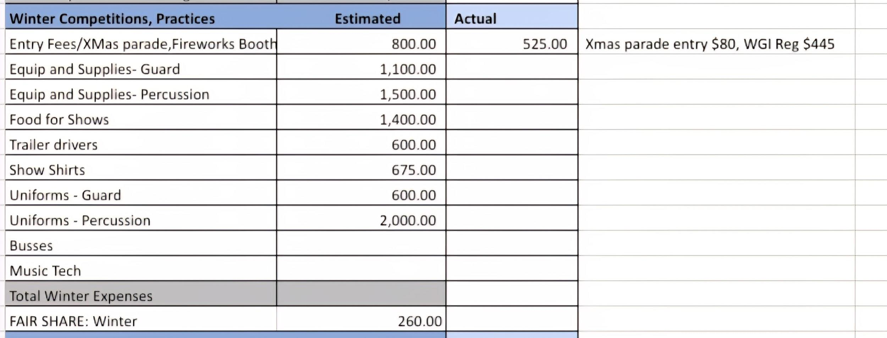

- Band Director Report - Mr. Medina
  - Board Introductions
    - Fund Raising- raise as much as possible. Prop 28 funds uncertain year to year. Need both adult and student support.
    - Instrumental Concert
      - Thank you for coming out, I believe it went well
      - I learned a lot that night and feel like I can plan better for the next concert
    - Secret Santa
      - Jazz Band, Orchestra, Concert Band participating in Secret Santa
      - Participation Optional
        - Orchestra and Concert Band Secret Santa will happen on Thursday 12/16
    - Winter Percussion/Winter Guard
      - December
        - WP: 12/18 5:30-8:30pm
        - WG: 12/17 2:30-5:30pm
      - January before school starts
        - WP Camp: 1/8 and 1/9, 10am to 9pm
        - WG: TBD last week of winter break?
    - Winter Season Fair Share- provided by our treasurer.
      - It is crucial that students pull in their fair share. If students can fundraise or bring in more, even better.
    - Fundraising
      - Gift wrapping fundraiser starts on 12/19 is an important one and we need help from everyone, but more so WG and WP members. We also need parent/guardian support.
      - Our board members will be there throughout, out of the goodness of their hearts, but they do have lives too so if everyone can sign up for at least one shift then that would go a long way.
      - Boosters are still needing donations for the gift wrap fundraiser.
        - T-Shirt boxes, bows, name stickers, tape, scissors
    - Winter Season Purchases
      - WP Uniforms purchased
      - WP show “Trapped”, abstract show with a cage as the prop
      - WG considering a different route for uniform purchasing
      - WG show “Yellow” (alternate version of Coldplay’s song)
        - More vibrant, no props
        - Rifles have been purchased for winter guard
      - In the works:
        - WP Equipment (sticks, drumheads, mallets?)
        - Show Registration Fees

- Choral Director Report – Ms. Carbajal
  - Carolfest at Stan State was a great success!
  - The choir is scheduled to perform the National Anthem at a few home basketball games and wrestling matches when we return from break.
  - The portable PA system has arrived! The condenser microphones are back ordered. When they arrive we will have a whole portable system for choir to use at any campus or community event and be heard!
  - The rest of the new choir dresses arrived last week. Since we did not have the full inventory for everyone to wear for the Holiday concerts, my goal is to have them ready to go for festival season in March.
  - We have plenty of choir robes, all still in great shape. The choir stoles have disappeared. We only have 17 stoles inventoried at the moment. There should be a box somewhere in this building, we just need to find them. We have the possibility of ordering new robes/stoles next year, so I’m not too worried. The robe design and fabric we have are not in production anymore.
  - Mrs. Carbajal is requesting the use of Prop 28 funds for a final music & storage library purchase. The total cost should be between $400-$600. Each school site with a choir was allotted $1000 to use for music purchases for the school year. Since our choir is one of the largest in the district now, we have already gone through that cost with the first 2 concerts and the Honor Choir materials. IF the cost is not approved through the school site, I may turn to boosters for some help.

- VP of Service Report – Lauren Odermatt
  - Feeding WP on Saturday practice
  - Chaperone needed for Coralfest
  - Working on donations for pancake breakfast which will be held in February. We will need adult and student volunteers. There will be a silent auction basket raffle.
  - Weekly contact with Bella (WG) regarding color guard.
- VP of Fundraising Report – Kim Ricci
- Gift wrap fundraiser- this Friday the 19th through the 24th at Best Buy
- Need adult and student volunteers. Please sign up on Sign-Up Genius.
- Profit- 60% to the general booster fund, 30% to the student volunteer Cut Time ledger (based on hours worked) and 10% to the adult volunteer (to be credited to their student cut time ledger).
- QR code scannable to sign in and out of shifts- timestamped
- Adults ONLY handle cash

- Secretary Report- Alli Campbell
- Google order form for Beyer Music shirts and hoodies available. Went out in a Cut Time message on Sunday. Taking orders until 12/19 @ 1 pm. Payment to booster box via check to “Beyer Band Boosters” or cash in a sealed labeled envelope please. Both order and payment needed.
- If you are not receiving a weekly Cut Time message, please email beyerbandboosters@gmail.com so I can update your contact information.
- Follow @ Beyerindoor on IG for winter percussion updates.
- Discussion about what Fair Share is for parents who aren’t sure of what this is.
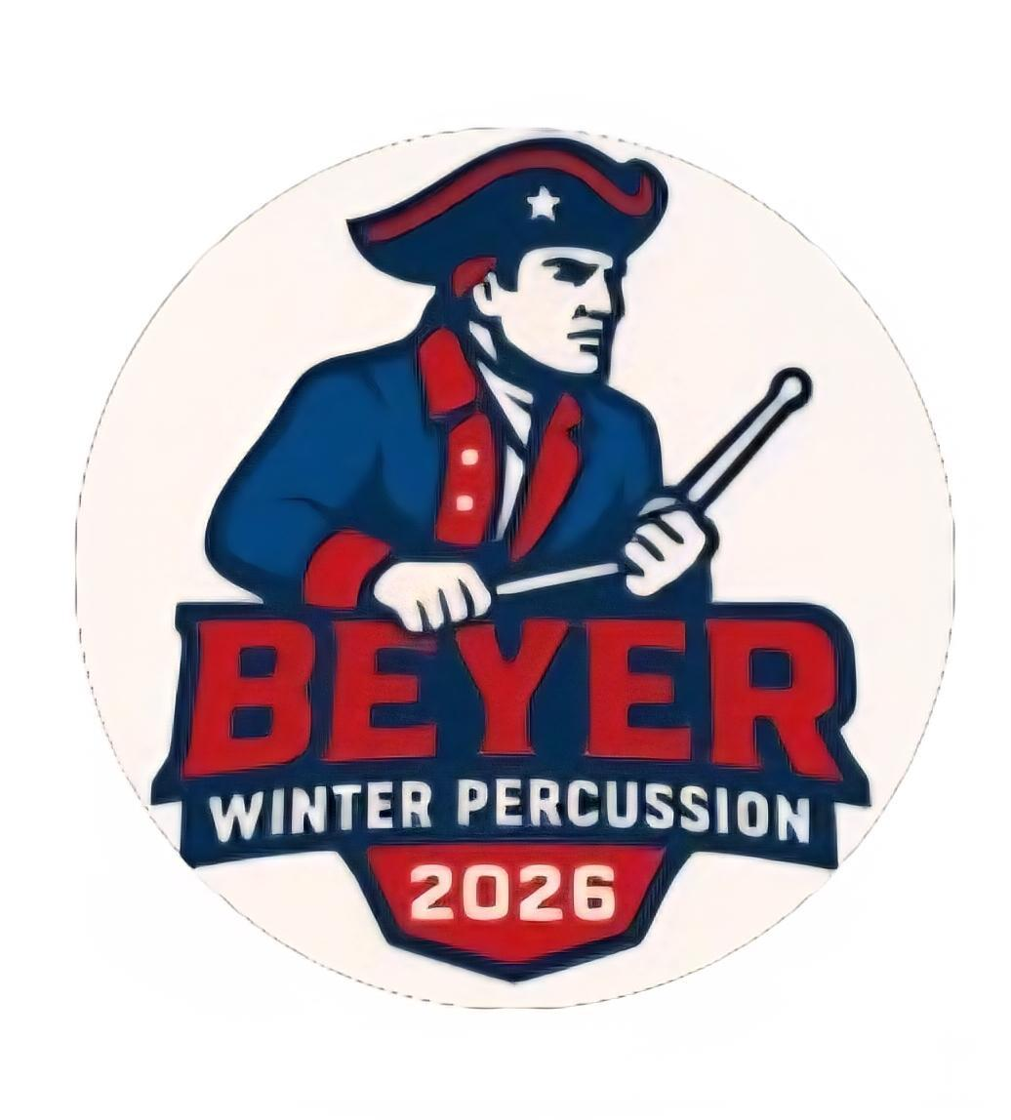
8. Blue Crew Chief Report – Bobby
  - Small trailer
    - Replaced rear brake/turn signal lights and license plate light.
    - Working on interior lights.
  - Winter Percussion Prop
    - Working on ordering material for the prop to be assembled over winter break.

9. President’s Report – Jeffrey Tallcott
- https://beyerband.org/how-to-donate
    - pay.beyerband.org

10. Other Business
a. Please stay up to date by subscribing (iphone users) to the Beyerband.org calendar OR checking your weekly Cut Time messages that are sent out via email or text.
b. You can always reach out to the boosters with any questions-
  - beyerbandboosters@gmail.com. We will respond within a few hours.

11. Next Parent Booster Meeting
- January 20, 2026, 6:30 pm at Beyer HS

- Meeting Adjournment @ 7:28 pm
  - 1st- Kim Ricci
  - 2nd- Tonya Barnard

