10/14/2024 Beyer Music Booster Parent
Meeting Agenda

Online Only due to student practice split between 2 campus

Download Teams | Join on the web
Learn More | Meeting options

This meeting to immediately follow the 7 PM
COMBINED meeting for the
Modesto City Marching Brigade (MCMB) - Enochs and Beyer Boosters
- 10 14 Music Booster Meeting Agenda/Minutes

Location: Virtual ONLY
BEYER MEETING: 7:37 pm

Attendees: Mr Medina, Ms. Carbajal, Alli Campbell, Jeff Tallcott, Lauren Odermatt, Eric Odermatt, Kim Ricci, Amanda Coons, Bobby Coons, Matt Jenkins

- Approval of previous minutes
  - 9/9/2025 Beyer Booster Parent Meeting

- Treasurer Report – Amanda Coons
  - Band Boosters Treasurer Reports 24-25.xlsx
  - Taxes-Non profit taxes 24/25 school year.

- Band Director Report - Mr. Medina
  - Kyoto Gift Exchange Assembly
    - Band students performed “Sweet Caroline”, it went great. Got praise from the principal and former leadership teacher of mine.
  - MCMB
    - Show Days
      - 10/25 Clovis High School (Clovis)
      - 11/1 West Park High School (Roseville)
      - 11/15 James Logan High School (Union City)
      - 11/22 (23?)- still waiting for WBA to post the location
    - Please help support your student and/or the band and sign-up to volunteer. Thank you to those parents who have been volunteering.
  - Concerts
    - Orchestra & Jazz Band Concerts postponed
      - Jazz Band - Thursday December 4th, 6pm start in the Little Theater. They are going to be playing some challenging pieces.
      - Orchestra - Tuesday December 9th, 6pm start. Joint concert with Concert Band.
    - Concert Band scheduled-
      - Tuesday December 9th with Orchestra, in the Forum.
  - All-State Auditions- Chris, Nick and Logan
    - In the process of editing, uploading, and submitting audio auditions by Wednesday 10/15 before midnight. Missing one permission slip.
    - Fees have been paid for the only thing left is the one permission slip and to upload and submit recordings. Students can listen to their recording before I submit.
  - SCMEA Auditions
    - Orchestra Auditions
      - November 13, 2025 @ 6pm @ Modesto HS. Material has been passed out to the students. Many students are interested in auditioning.
    - Concert Band Auditions
      - December 2, 2025 @ 5-7:30pm @ Pitman HS. Material should be passed out to the students this week.
    - ENCOURAGE YOUR STUDENTS TO AUDITION
  - Classes
    - Jazz (Sing, Sing, Sing) & Concert Band (Alligator Alley)- doing great, learning some difficult pieces.
    - Orchestra- students reauditioned and they did way better than the first auditions. There will be some tough calls on where to place people. There are many talented individuals. Reaudition was a teachable moment for the students to do their best. Results will be posted in class on Friday.
  - Winter Season
    - In discussion on Winter Season with Jorgey and Hannah
      - Getting the ball rolling, logistical things to sort out
      - The goal is to add some staff to the Winter program.
      - A lot of interest this year, encourage your students to join. More so Seniors, parents please encourage your underclassman to participate so we can grow a strong music program.
    - Winter Percussion
      - Hannah is in the process of picking out a show. Hoping for an update on the budget for winter.
    - Hannah (rep for me) and Rogelia went to the CVGPA meeting
      - Beyer will be hosting with Enochs at Champs this upcoming winter season. Will discuss the possibility of hosting a second show.
  - Fundraising/Donations
    - Money goes to music, instrument repairs, staff, uniforms, events (String Day at MJC), bus transportation, the more money that can be raised the less the question of “is this financially possible?” will arise.
  - Thank you for supporting the students!

- Choral Director Report – Ms. Carbajal
  - Discussed in the joint meeting.
  - Getting a new portable sound system.

- VP of Service Report – Lauren Odermatt
  - Helped serve students lunch at the 9/9 practices.
  - November 13th will need help with handing out the pie orders. Not sure if Enochs will have an adult rep there. Per Kim, she made it clear to Enochs that we will need help from them. Someone needs to be present, from Enochs, to help on that day.
    - Per Kim- Pie delivery at 2:30 pm. Will be broken down by student orders. Parents show up, look for the student name and hand them their order.

- VP of Fundraising Report – Kim Ricci
- Pie Fundraiser dates- student sales October 20th thru the 31st.
  - Pie pick up on November 13th at 3 to 5 pm. PIES MUST BE PICKED UP, we do not have the ability to store pies.
  - All MCMB students' sales will go towards the remaining cost needed to cover the fall season expenses. This cost is what is left over from not meeting the total Play A Thon fundraiser’s goal.
  - All other music students will have their profit added into their Cut Time ledger.
  - December fundraiser- gift wrapping at Best Buy
    - Donations needed- scissors, shirt boxes, tape, gift wrap, bows (Dollar Store). Sign-Up Genius needed.
    - Gift wrap dates 19th thru 24th- need volunteers and trailer drivers. Sign-Up Genius needed.
    - Provide snacks and hot chocolate for our students maybe?
    - Jazz performance? Choir performance?
  - Parent Question/Suggestion
    - Performance at retirement homes? A parent brought up this possibility, voiced concern that the focus is on marching band.
    - Mr. Medina will consider this. Will follow-up with Director’s regarding community outreach.. Maybe we can utilize the Jazz Band or Orchestra for this?
  - January- Rocky Mountain Chocolate fundraiser

- Secretary Report- Alli Campbell
- Student shirts ordered for all music classes are ready for pick-up tomorrow. Amanda has already paid for them. Every student in Jazz Band, Concert Band, Orchestra and Choir will receive a shirt. The Choir will have them in time for their first concert on Tuesday the 21st. Extras were ordered. Came in under budget on the shirts.

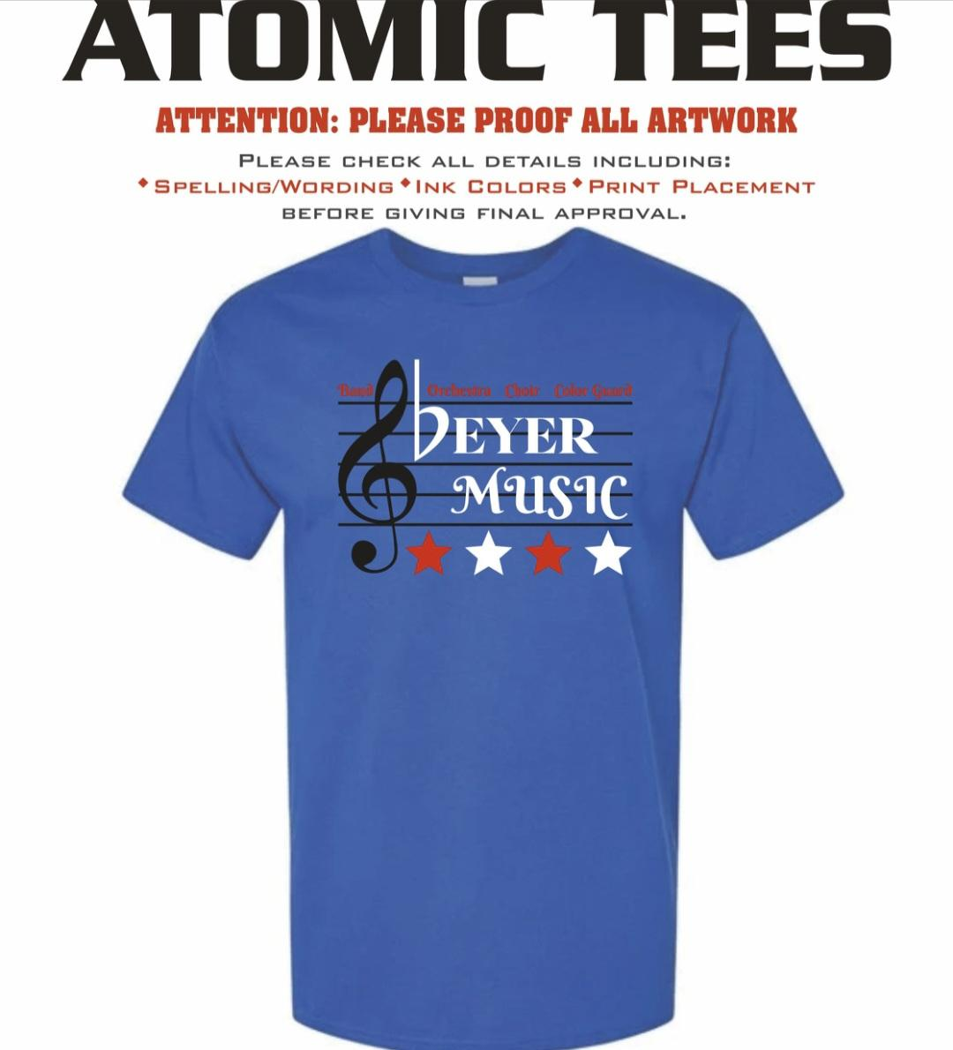

- Anyone who has a senior and wants to donate time, money or products to make this year’s senior dinner memorable, please reach out to the boosters via the email listed above. Senior dinner will take place at the regional competition in Union City on 11/15.
- Will reach out to the Senior parents again. If there are Senior parents missing from the GroupMe “Senior” feed then I will reach out to each of those parents to see if they would be available to get involved in planning and preparing.

- Blue Crew Chief Report – Bobby Coons
  - The flatbed trailer got new tires and bearings serviced. Along with a storage container for straps and cribbing for the props.
  - The large trailer had the emergency brake battery controller replaced. electrical and lights were updated so they no longer use the brake battery.
  - The small trailer had the emergency brake battery controller replaced and the trailer wiring updated. Interior electrical and lighting will be updated once marching season is finished.
  - Generators will be taken to Beyer small engine class with Mr. Wolf for service and repair.
  - Props will get recessed anchor points to remove the rope leads to allow the use of metal handles. Working to make them easier to move.
  - New bag for the PVC pipe props.

- President’s Report – Jeffrey Tallcott
  - The BeyerBand.org (2005) website is now BeyerMusic.org.
  - In future, both sites will continue to work.
  - Trying to fix the calendar to see details when you click on an event within the calendar.

- Other Business
  - Please stay up to date by subscribing (iphone users) to the Beyermusic.org calendar OR checking your weekly CutTime messages that are sent out via email or text.
  - You can always reach out to the boosters with any questions- beyerbandboosters@gmail.com. We will respond within a few hours.

- Next Parent Booster Meeting
  - November 18th @ 7 pm in the Beyer Little Theater.

- Meeting Adjournment at 8:20pm

