Beyer Parent Meeting: Led by Booster President, Julie Chavoya

Date: January 23, 2025
Place: Beyer’s Little Theater
Start Time: 7:00 pm

- Approval of Previous Minutes from December 12th
  - December Board Meeting Minutes
    - 1st- Amanda Coons
    - 2nd- Kim Ricci

- Treasurer Report- Amanda Coons
  - “December” (sheet 4)- parents please review and feel free to reach out to the boosters with any questions
    - Income $18,565.05
    - Expenses $28,172.44
  - Booster checking account balance as of January 20, 2025= $32,457.67.
  - Disneyland account balance as of January 20, 2025= $13,450.

- Winter Budget- 24/25 Live Document Draft
  - Student Fair Share Amount
    - Total estimated winter program expenses: $9980 estimated cost, divided among 31 winter percussion/guard students. Boosters are asking for $320 in “fair share” to be collected per student through fundraising efforts or direct payment to their music account.
      - Many students have already covered their fair share through fundraisers and are now able to fundraise and use account overpayments towards the cost of their Disneyland trip.
  - Review of Expenses (see “Winter Budget” link above)
    - Entry Fees- budgeted amount is for one show’s entry fee and the cost of registering for the downtown Christmas parade.
    - Equip. and Supplies for Winter Guard- a bench (prop), silks for two different show flags and a new speaker have been purchased.
      - Budgeted amount was also for the purchase of new sabers and rifles. These are back ordered until 2026.
    - Equip. And Supplies for Winter Percussion- half the cost of the show floor, cost of sewn 20’x15’ blue fabric to make the show’s “ocean water”, cost of supplies to construct the sun prop (paint still needs to be purchased).
    - Food Budget- to feed students at two shows. The March 1st show was canceled and a Saturday practice was added for that same date. Boosters will feed the students dinner at this practice. See Director’s Report.
    - Trailer Drivers and Busses- expense to transport students and equipment to away shows.
    - Show Shirts- all winter performing students will receive a show t-shirt. Students who want a sweatshirt will need to purchase those separately. Parents/families have the option to purchase a t-shirt or sweatshirt. Pre-order and pay at pick up. See President’s Report.
    - Uniforms-
      - Guard- $250 deposit was submitted by boosters. Purchase order sitting in accounting for district approval and payment of the remaining balance.
      - Percussion- uniforms ordered. District paid for half. White shoes purchased for the students. Amount slightly over budget.
    - Staff Polos- $350 budgeted for winter instructional staff polo shirts. To be ordered soon.

- President’s Report- Julie Chavoya
  - Fundraisers
    - Zoe’s Coffee- our current fundraiser for January. Students were asked to sell bags of coffee. They get 40% profit from their sales. Money and order forms are due January 27th.
    - Pancake Breakfast- event date is on Saturday, February 22nd.
      - Scrip (tickets) sold by students starting on January 27th, (the day the coffee fundraiser ends). Scrip sales are due Feb. 13th. Scrip is $15 each. Students earn $6 per scrip sold towards their music account (fair share and Disneyland trip expenses).
      - Beyer’s jazz band will be performing.
      - Menu- eggs, bacon, pancakes, juice, coffee.
      - Silent auction- in need of donations for the silent auction.
      - Parent help at this event would also be appreciated..
    - Las Casuelas Restaurant (Sylvan Ave) - March fundraiser.
      - Drive thru and pick up dinner. Chicken and carnitas with rice.
      - $15 ticket. Kids make 40% of ticket sales, the other 60% goes back towards the restaurant.
    - Gift Wrap Fundraiser
      - Student Cut Time music accounts have been credited for their participation. We raised over $6,000. Parent’s received 20% and students received 80% credit of the donations received on the shift that was worked. The highest earner received nearly $1100 towards their student account.
  - Cut Time (Communication App)
    - Student music account balances are available in the financial section. All transactions are listed such as fundraiser credits, parent direct payments and deductions towards “fair share” balance and the upcoming Disneyland trip.
      - Winter fair share cost of $320 will be applied to the accounts in February to allow students to fundraise and earn money in their accounts before seeing that added expense.
    - The next Disneyland payment is due January 25th. AFTER THE COST OF FAIR SHARE HAS BEEN MET, any overpayment in a student’s account will be applied towards the Disneyland trip. If the student account is “in the red” and Disney payment hasn’t been received then Julie will reach out for payment.
  - Show Shirts
    - Provided for each winter season performing student.
    - Two designs (one for percussion and one for guard) were created by Tristen, a student in our winter guard.
    - Families have the option to pre-order. T-shirts are $12, hoodies are $23.
    - Use this link to preorder-https://forms.gle/5v8Fuka3ed6vzCgR6 or scan the QR code below. Pre orders are due by February 1st.
    - A Cut Time message will be sent out with the link to order.
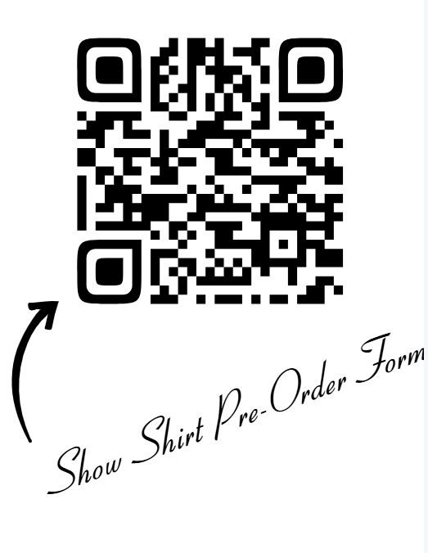

  - Help Needed at Guard and Percussion Shows
    - Help is needed to move props, the very heavy show flooring and percussion equipment on and off the show floor when our guard and percussion students perform.

- Secretary- Alli Campbell
  - Stay up to date by visiting BeyerBand.org. Parent meeting minutes are available on the website, under the “Band Boosters’ tab. I will try to post new meeting minutes on the website within one week of our meeting date.

- VP of Service- Priscilla Little
  - Passed out a list for parents attending this meeting to add their contact information.

- VP of Fundraising- Kim Ricci
  - Coffee Fundraiser- sales end this Monday. Adults please look over the order forms and verify the coffee orders, payment amounts and that the form is legible.
  - Pancake Breakfast- scrip to be handed out right after the Zoe’s Coffee fundraiser ends on Monday.

- Blue Crew Chief- Jeff Tallcott
  - Coordinates care and transportation of all of the equipment.
  - Trailers and Parent Help
    - Please see Jeff to provide your contact information if you have a truck and are willing to help with towing needs.
    - We have two trailers. A 24 ft trailer that carries between 6,000 and 12,000 lbs and a smaller 16 ft trailer that can be towed by a ½ ton truck.
  - Bobby Coons designed and constructed our winter percussion’s sun prop for the show. The sun prop is much lighter than the props used for the Fall season, allowing the sun to sit upright. It’s in two pieces and can be rolled onto the show floor. Hopefully it will be painted this weekend.

- Band Director’s Report- Mr. Winkler
  - Winter Schedules and Shows
    - Winter Percussion- March 1st South Valley Circuit (new circuit) show planned is now canceled due to being waitlisted and then not making it onto the final schedule for that show. This date has been changed to a Saturday practice from 10 am to 9 pm.
    - Winter Guard- March 1st planned CCGC show canceled (Bay Area circuit, Fremont). No practice added for this day.
  - Winter Show Hosting
    - March 15th- co-host with Oakdale HS at Enochs HS
    - March 29th- (Champs) co-host with Enochs HS at Enochs HS.
    - Central Valley Guard and Percussion Circuit (CVGPC)
      - They use facilities in our local area for the winter shows. Different ensembles/schools have the chance to host a show and raise funds towards their individual music programs. At the end of the season the circuit takes all of the profits and will split them among all of the high schools who hosted that season.
        - Last year Beyer’s music program made $5000 through this fundraiser.
    - Host Responsibilities
      - Split between both schools hosting.
      - Parent and student volunteers are needed to sell admission tickets, run concessions, monitor the doors entry and exit of spectators and performers, be a judge runner (student position), provide first aid, sell air grams (shout-outs to performers), be a parking attendant and coordinate/assist with the director and judge’s hospitality room.
      - Any handling of money must be done by an adult.
    - Host Sign-ups
      - Information and sign-ups will go out once we receive more information from the circuit.
      - The event time varies. It can run from 7 am (show set-up) to 6-8 pm (awards) depending on how many schools are performing.
      - Volunteers work 3 to 4 hour shifts throughout the day.
      - Volunteers get into the event for free.
  - Disneyland- April trip for Beyer and Enochs band, orchestra and choir students.
    - Ten chaperones and 41 students from Beyer.
    - Student Room Assignments
      - Students will receive a form next week to list their preferences for roommates. Directors will create the rooming list and try to honor student roommate preferences.
      - Beyer students room together and Enochs students room together. Six students per hotel room with two queen beds and one pull out sofa.
    - Chaperones Room Assignments- two to a room.
  - Future Performances
    - March- the first music festival will be the MCS Festival. Students travel to Downey HS to participate.
    - May-
      - CMEA Festival- where student’s will need to defend their superior ratings.
      - Awards Night- all music and guard students receive their blocks, chords for graduation (if requirements met) and individual recognition awards.
      - Spring Concert- scheduled for May 12th and 13th for Orchestra, Concert band and Jazz band. I do not know which groups are performing on which night yet.
        - Working with Somerset middle school's new Director to have them join us at our May concert.
      - Graduation Performance- the senior’s parents last time seeing them play with the band. The band plays “Pomp and Circumstance” for the processional of all Seniors. The band seniors then join the band and play a final piece together.
  - Guest Artist
    - Dr Brett Abigana, a professor and composer from Boston University who has written pieces for the USAF band, Juilliard and various groups and artists throughout the world.
    - He is writing a piece of music for Beyer HS. The hope is to have him here for our May concert where our band will perform the world premiere of that commissioned piece. Boosters are making it possible for him to fly out. We are awaiting his schedule to see which night (May 12th or 13th) he will be available to visit.
  - Parent Communication
    - Booster communication is sent through an app called “Cut Time”. Make sure Julie Chavoya (President) has parent contact information (email, phone number) so that you can receive messages. Turn push notifications on.
    - Director communication is sent through “ParentSquare”. Students from other schools will get put into the “Colorguard” class and will receive those notifications.

- February Meeting Date: Thursday, February 13, 2025 at 6 pm for the board meeting and 7 pm for the parent meeting.

- Meeting Adjournment: 7:42 pm
  - 1st- Alli Campbell
  - 2nd- Amanda Coons

